where 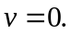
Papers written by Australian Maths Software

SEMESTER ONE

REVISION 1

MATHEMATICS METHODS
UNIT 3

2016

SOLUTIONS

SECTION ONE
1. (7 marks)
(a) 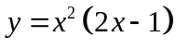 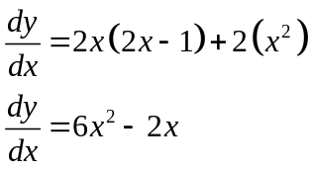 ✓✓ -1/error (2)

(b) 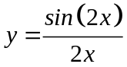
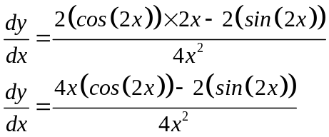
✓ ✓

✓

(3)

(c) 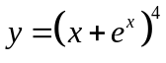
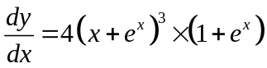 (2)

✓ ✓

2. (9 marks)
(a)
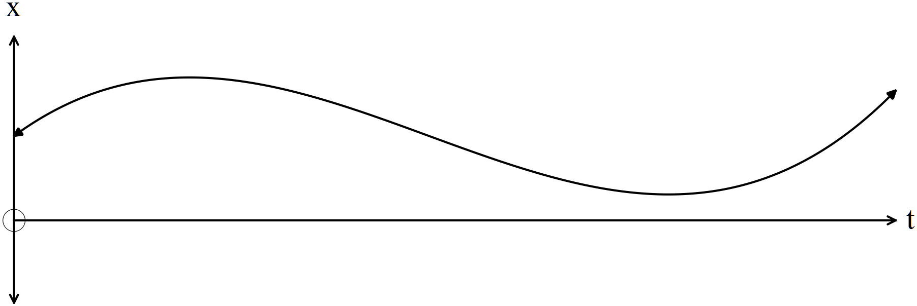
✓✓

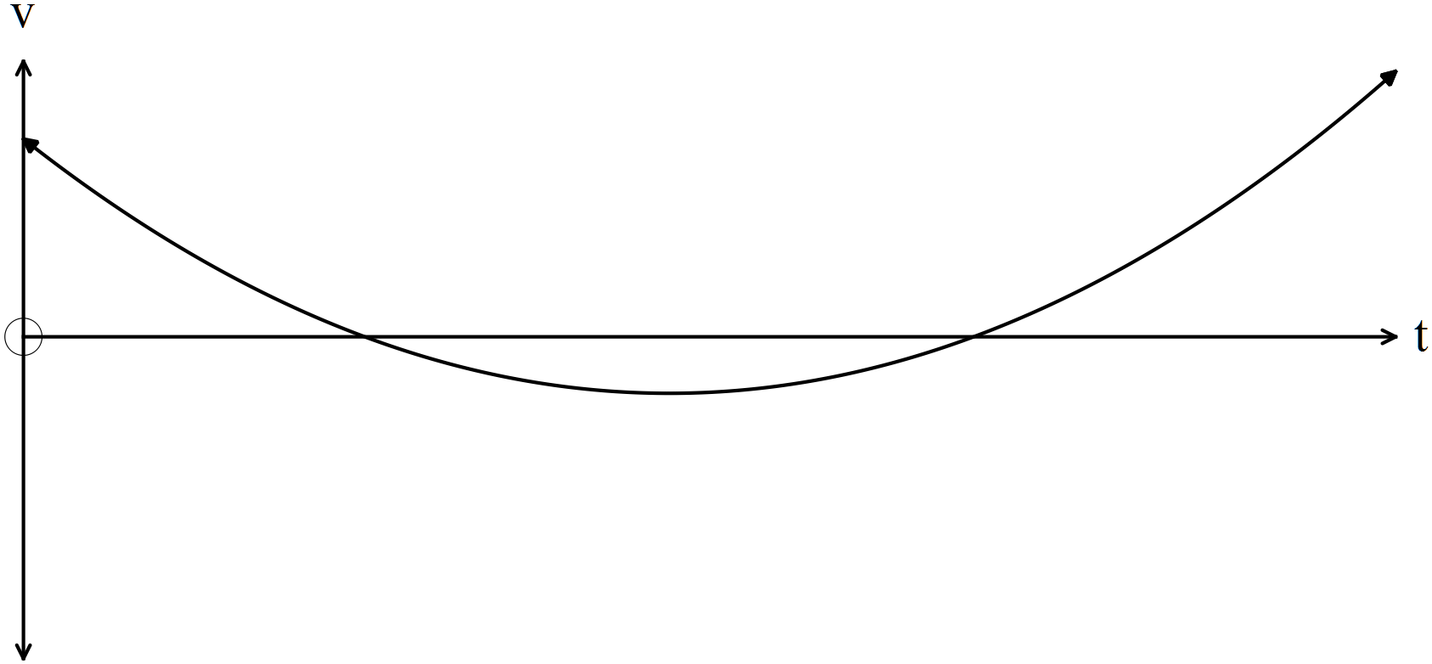
✓✓

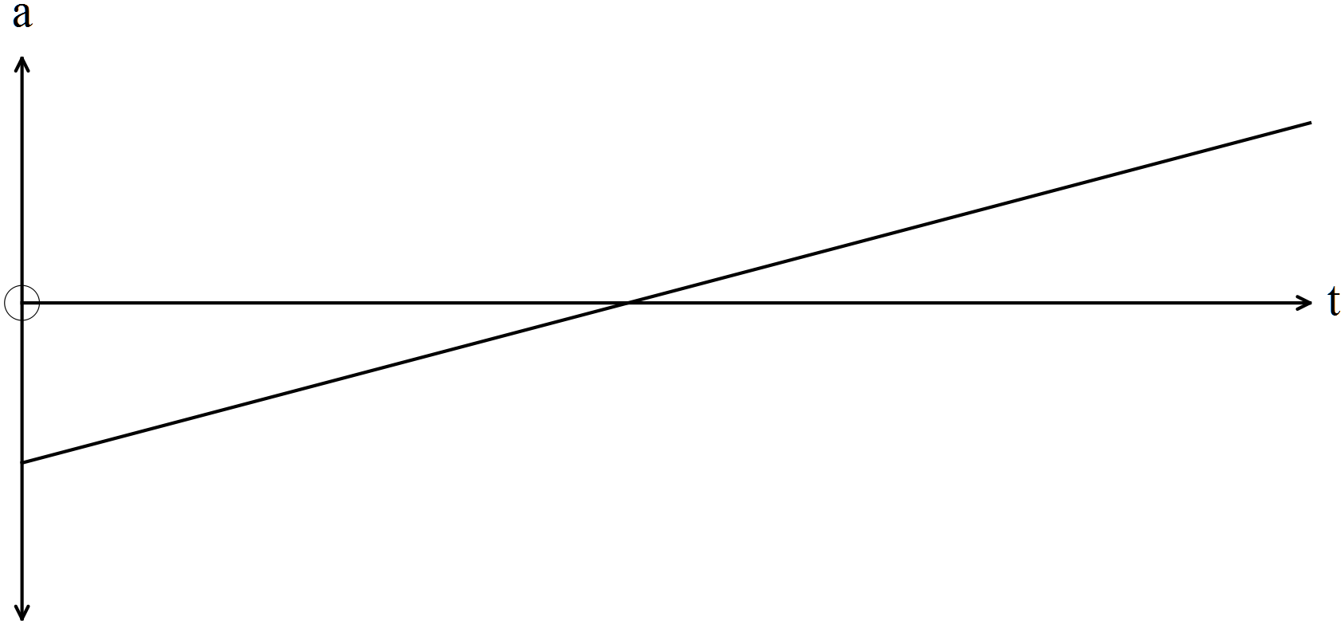
(4)
(b) The displacement graph is a cubic polynomial. ✓ (1)
(c) At 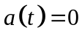 on the acceleration graph, there is a point of inflection on the displacement
graph. ✓ (1)
(d) At , the velocity graph has a turning point. ✓
In this case the velocity goes from decreasing to increasing so the velocity graph has a
minimum turning point. (1)

(e) At 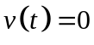, then the particle changes direction on the displacement graph. The velocity
goes from positive to negative or from negative to positive. ✓ (2)
On the displacement graph, the first time the displacement had been increasing
and the particle turned around and began decreasing.
The second time , the displacement had been decreasing and the
particle turned around and began increasing.

3. (6 marks)
(a) (i) 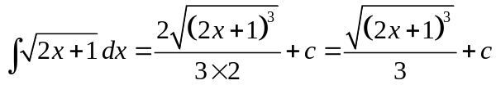 ✓ ✓ (2)
(ii) 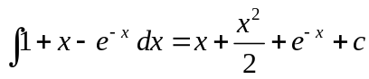 ✓ ✓ (2)
(b) 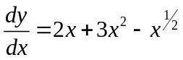
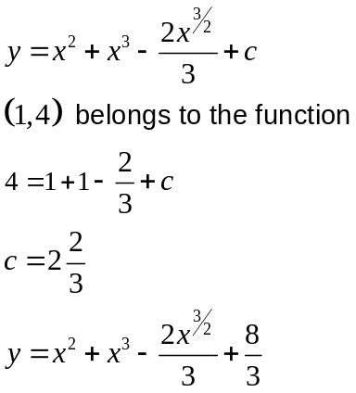
✓
✓
(2)
4. (7 marks)
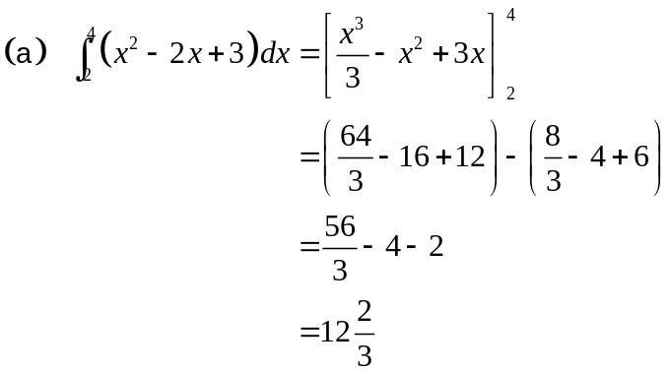
✓
✓
✓
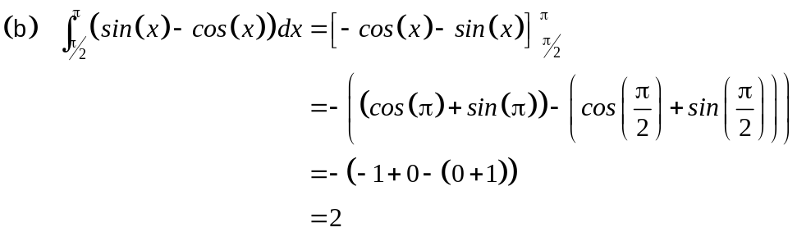
✓
✓
(2)

(c) 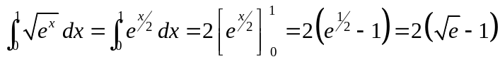 (2)
✓ ✓

5. (5 marks)
(a) (i) 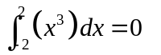 ✓ (1)
(ii) 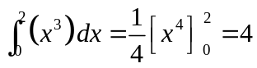 ✓ (1)
(iii) Area = 2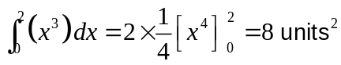 ✓ (1)
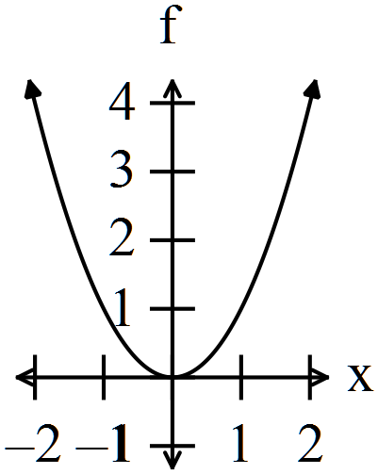
(b) (i) 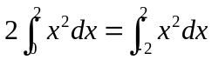
✓
True as the function is
(a) symmetrical about the y axis
(b) not below the x axis. (1)

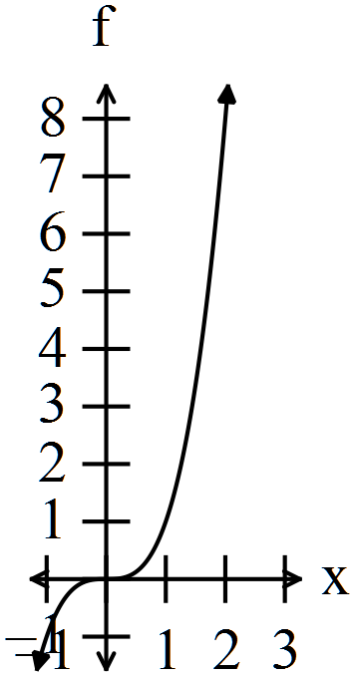 (ii) 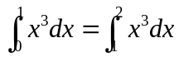
✓
False as the graph has different y values
on the different domain. The area below
the curve is different on the same base
as the height of the curve changes. (1)

6. (8 marks)
(a) If 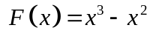
(i) 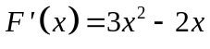 (1)
✓

(ii) 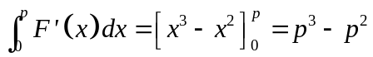 ✓✓ (2)
(b) 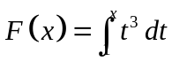
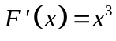 ✓✓ (2)
(c) 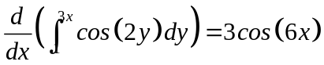 (3)
✓ ✓ ✓

7. (8 marks)
Given
(a) (i) 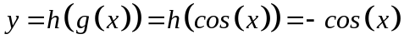 ✓ (1)
(ii) show 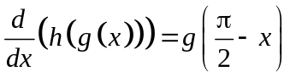
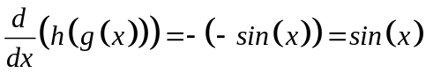 ✓
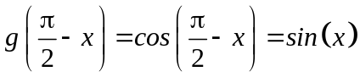 ✓
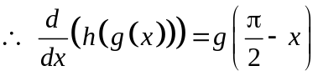 (2)
(b) (i) 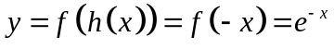 ✓ (1)
(ii) 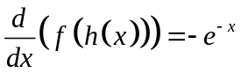 ✓✓ (2)

(c) 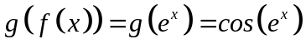 ✓
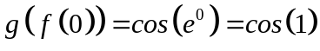 ✓ (2)

END OF SECTION ONE
SECTION TWO
8. (4 marks)
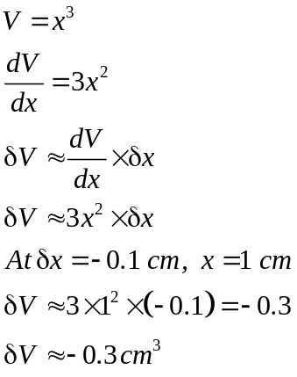
✓
✓
✓
✓
The decrease in volume when the side has melted to 9 mm is 0.3 cm³ (4)

9. (10 marks)

(a) (i) Not a probability density function as the total is only 0.9. ✓ (1)
(ii) Not a probability density function as you can’t have a negative
probability. ✓ (1)
(ii) Is a probability density function as the total is 1. ✓ (1)
(iv) Not a probability density function as you can’t have a probability
greater than 1. ✓ (1)

(b) (i)
y | 1 | 2 | 3 | 4 | 5 | 6
P(Y = y)

✓
(1)
(ii) 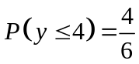 ✓ (1)
(iii) 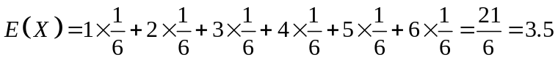 ✓
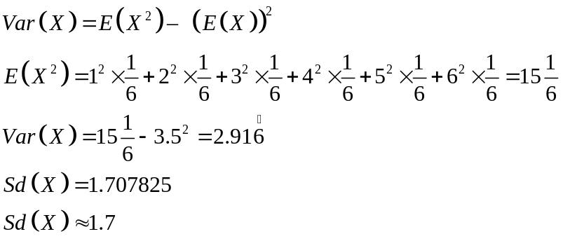
✓
✓
✓
(4)
10. (8 marks)
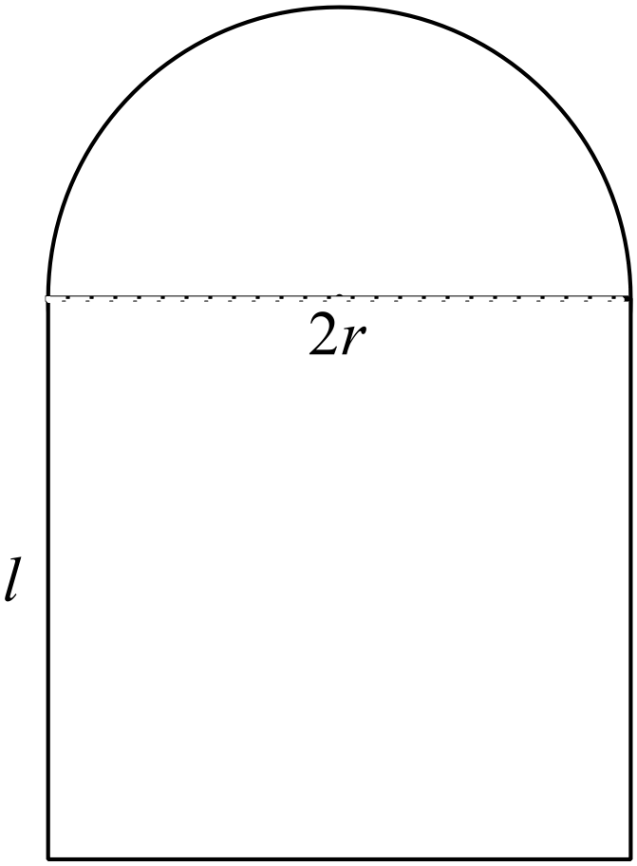
✓
(a) 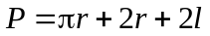 (1)

(b) 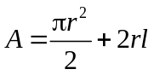
But 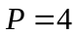
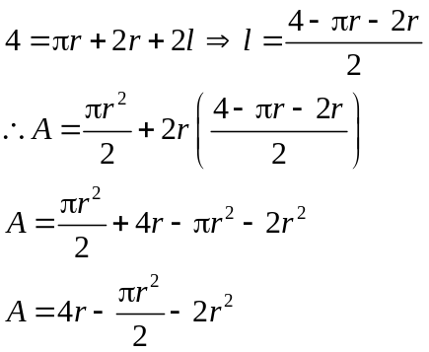
✓
✓
(2)
(c) 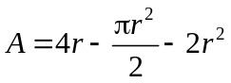
✓
Maximum area occurs when 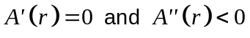
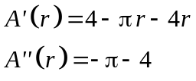
✓
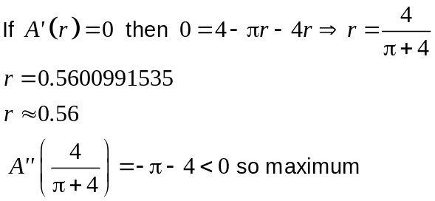
✓
✓
✓
At 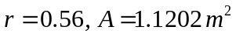

The maximum area of the window is 1.12 m². (5)

11. (6 marks)

(a) 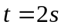 ✓ (1)
✓
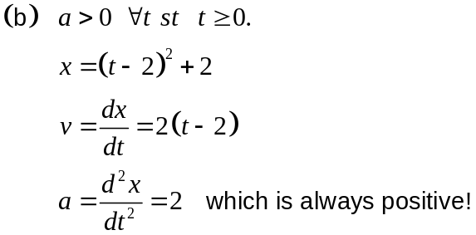
✓
(2)
(c) 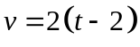
At 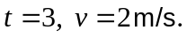 ✓ (1)

(d) Distance travelled for 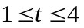=?
✓
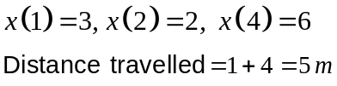
✓
(2)
12. (7 marks)

(a) (i) (3)
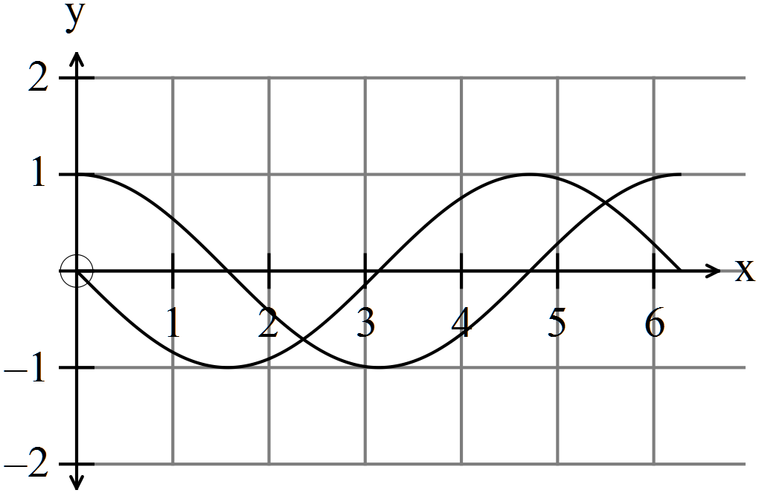
✓
✓
✓
(ii) Point shows where the maximum gradient is. (1)
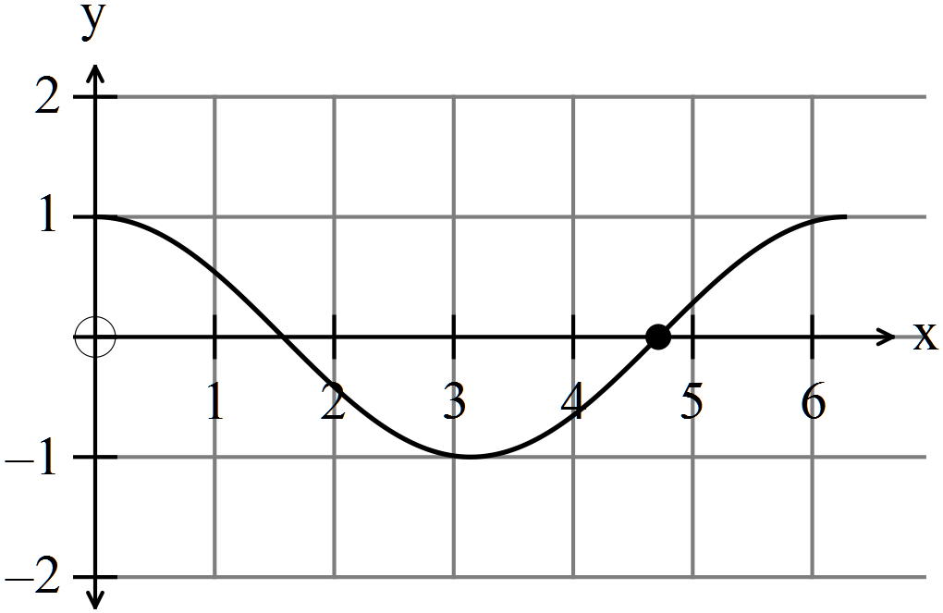
✓
(b) If 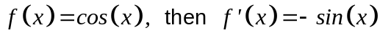 ✓ (1)
(c) 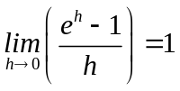 ✓✓ (2)
13. (5 marks)
(a) 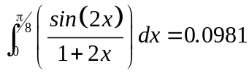 ✓✓ (2)
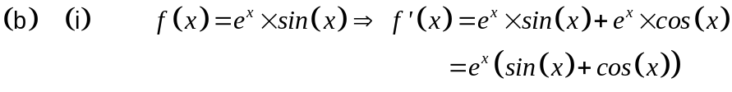
✓
(1)
(ii) Hence
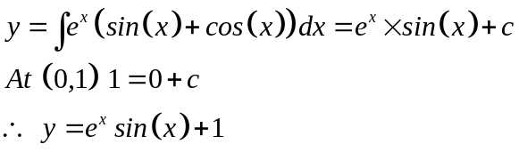
✓
✓
(2)
14. (9 marks)

(a) 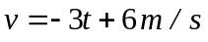
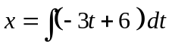
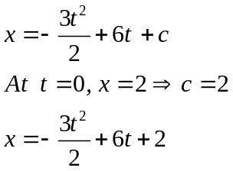
✓
✓
(2)
(b) 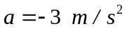 ✓ (1)
(c) 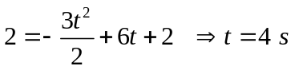 (2)
✓ ✓

(d) Changes direction when 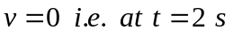 ✓
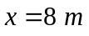 ✓ (2)
(e) 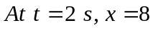
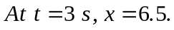 ✓
The distance travelled in the second is 1.5 m. ✓ (2)

15. (13 marks)
(a) (i) 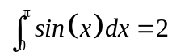 ✓ (1)
(ii) 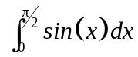=1 An estimate cab be made because the graph
is symmetrical. ✓ (1)
(iii) Area = 8 units² ✓ (1)
(iv) 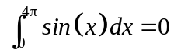 ✓ (1)
(b) (i) Estimate from below
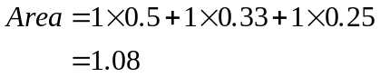 ✓✓
Estimate from above
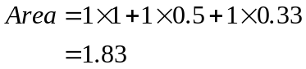 ✓✓ (4)
(ii) 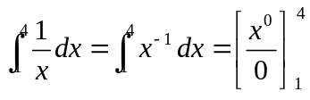 ✓✓
Conventional methods do not work as you cannot divide by zero. ✓
(3)
(iii) 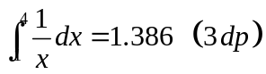 ✓✓ (2)
16. (8 marks)
(a) 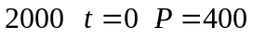
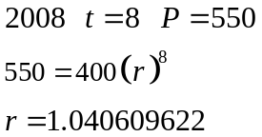
✓
✓

The annual rate of increase of the population of numbats was 4.06%. (3)
✓

(b) 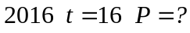
✓
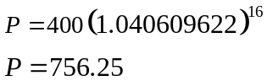
✓
The expected population in 2016 is 756 numbats. (2)

(c) 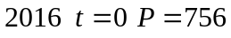
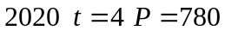
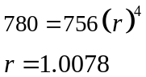
✓
✓
The rate of increase has dropped from 4.05% to 0.78%.
✓
It is possible that predators had found a way in. (3)
17. (10 marks)
(a) (i)
✓ ✓

House | Hawke | Howard | Gillard | Turnbull
P(House) | 0.15 | 0.25 | 0.35 | 0.25
(2)
(ii) 0.15 + 0.35 = 0.5 ✓ ✓ (2)

(b) (i)
✓ ✓

House | Hawke | Howard | Gillard | Turnbull
P(House) | 0.25 | 0.25 | 0.25 | 0.25
(2)
(ii) A subset of a parent population with elements selected at random
can produce a different distribution to that of the parent population. ✓ ✓
(2)
(iii) P(the student is assigned to Howard or Hawke house) = 0.5 ✓ (1)

(iv) P(the student is not assigned to Turnball house) = 0.75 ✓ (1)

18. (9 marks)

(a) 0.00243 ✓ (1)
(b) 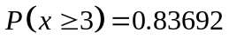 ✓✓ (2)
(c) 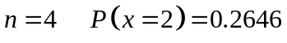 ✓✓ (2)
(d) 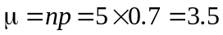 ✓✓ (2)
(e) 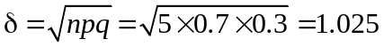 ✓✓ (2)

19. (6 marks)
(a)
 | HH | HT or TH | TT
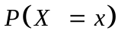 |  | 

✓✓

(2)
(b) (i) 0.0985 ✓ (1)
(ii) 0.8363 ✓ (1)
(iii) 0.9937 ✓ ✓ (2)

20. (5 marks)
Four Apple MacBooks Three ASUS
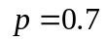 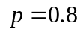 ✓
✓

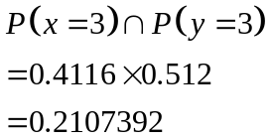
✓✓

✓

The probability that 3 Apple MacBooks and 3 ASUS are being used is 0.21 (5)

END OF SECTION TWO

